  
Headteacher

**Busbridge CE (Aided) Junior School**

**Brighton Road**

**Busbridge**

**Godalming**

**Surrey**

**GU7 1XA**

Telephone: 01483 417302

Fax: 01483 427852

Email: admin@busbridge-junior.surrey.sch.uk

Website: www.busbridge-junio.surrey.sch.uk

Mr Richard Catchpole BSc (Hons) PGCE NPQ

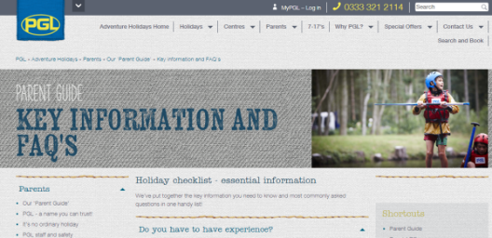

**Year 6 Windmill Hill 2024 Kit List**

* Walking boots (optional)
* Trainers for general activities
* Footwear that can get wet for water activities (old trainers, rock shoes. Not flip flops, crocs open-toed sandals)
* Swimwear x1 (for raft building activity)
* Socks and underwear for every day plus 2 spare
* Shorts x3 (please make sure that they cover the thighs for activities that involve climbing and harnesses)
* Trousers/ track suit bottoms x3 (no jeans as they will not dry)
* T-shirts/ shirts x 7 (include long sleeved)
* Jumper/ sweatshirt x3
* Sun hat/ sun cream
* Raincoat
* Pyjamas
* Cuddly toy for bedtime
* Towel x2
* Toilet bag with hairbrush, soap, toothbrush, toothpaste etc
* Torch
* Water bottle
* Pocket money £5 (in a named bag 5x £1 coins)
* Reading book
* Packed lunch for the first day in a disposable container. No fizzy drinks.
* Small pack of sweets we can share should children need a ‘lift’.
* Several plastic bags to put wet clothes in.
* Bag/holdall preferably with wheels as the children will carry their own bags
* Wet suits should not be brought as they will not dry!

This is a guide to what to take. Please feel free to amend this as you require for your own child’s needs.

NB. For medicines please refer to the medical form.

**Please ensure that everything is named.**

All bedding is provided. Safety equipment is provided.

No cameras, phones, electrical devices.

The PGL adventure holidays website has an excellent Parent Guide: Key information and FAQ section

<https://www.pgl.co.uk/en-gb/adventure-holidays/parents/our-parent-guide/key-information-and-faqs>